Project: LOG FILE ANALYZER FOR INTRUSION DETECTION

Name: Shugufta Sultana

---Elevate Labs---

Introduction
Cyber-attacks often begin with unauthorized login attempts. Monitoring authentication logs helps detect intrusion attempts early.
Abstract:
This project builds a Python-based log analyzer that detects brute-force attacks by parsing SSH logs, identifying suspicious IP behaviour, and generating alerts and visual reports.
Tools Used:
- Python
- Regex
- Pandas
- Matplotlib
- Linux Logs
Steps Involved:
- Collected authentication logs
- Parsed logs using Python
- Detected failed login patterns
- Counted suspicious IP attempts
- Generated incident reports
- Visualized attack behaviour.
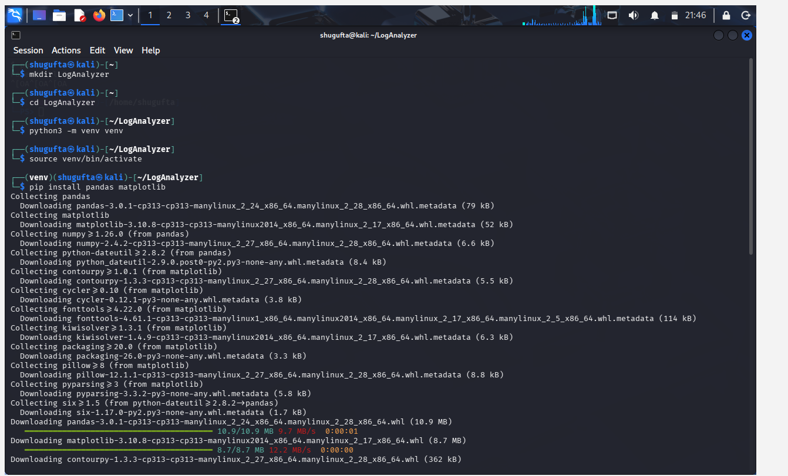
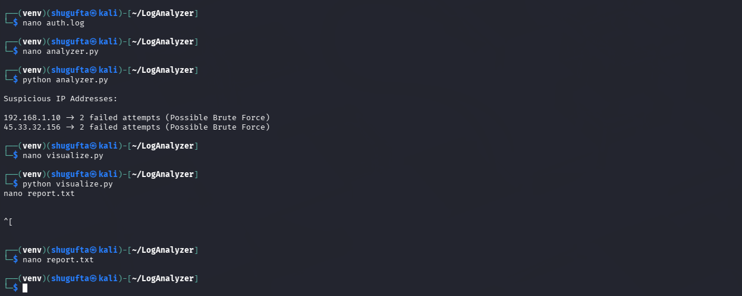
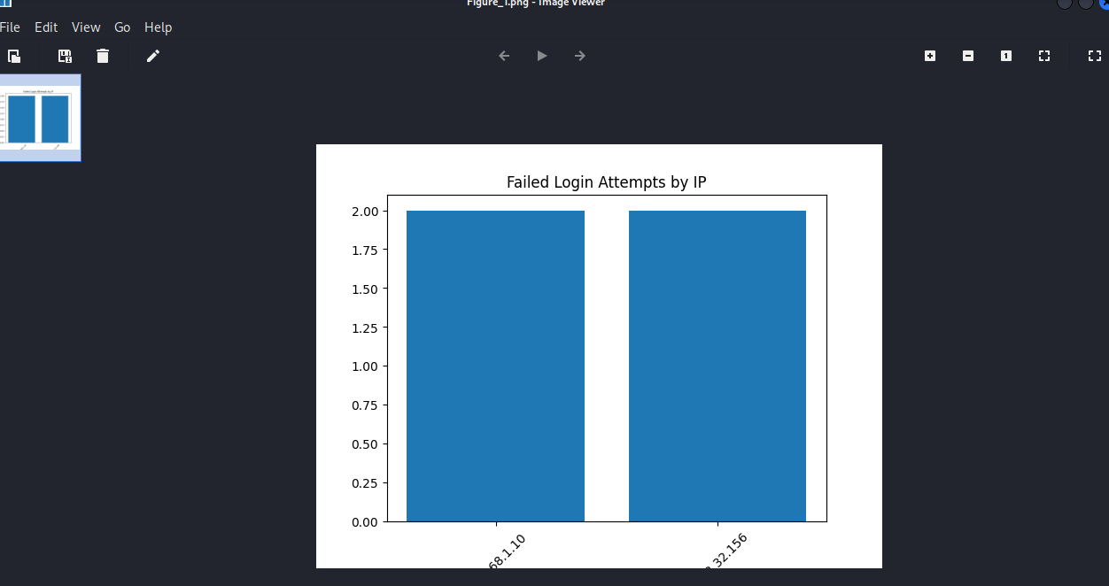

Conclusion
The project demonstrates how log monitoring enables proactive intrusion detection and supports SOC operations.

